Databricks LakeFlow + Delta Lake = Power Duo for Data Engineers 🌊⚡  
  
In today’s data world, speed + reliability + scalability isn’t optional — it’s essential.  
That’s where LakeFlow and Delta Lake come in! 🔄💎  
  
  
---  
  
📌 What is LakeFlow?  
LakeFlow is Databricks’ data ingestion & orchestration framework — your data highway 🛣️ to move information from sources → the Lakehouse seamlessly.  
✔️ Handles streaming & batch in one place  
✔️ Simplifies pipeline creation  
✔️ Built-in performance, governance, and monitoring  
  
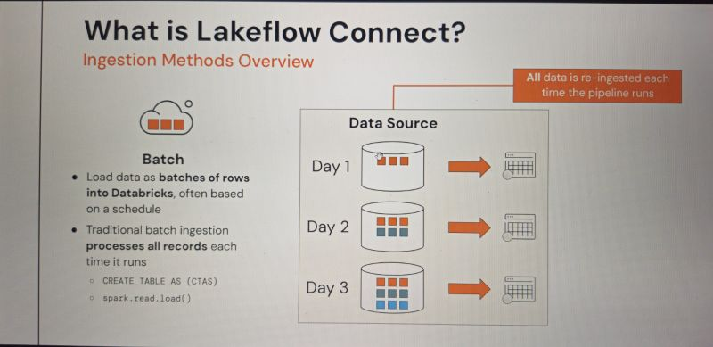  
---  
  
💎 What is Delta Lake?  
Delta Lake is an open-source storage layer that brings ACID transactions 🔐 to your data lake.  
Think:  
📂 Data lake flexibility +  
📈 Data warehouse reliability =  
🔥 One single source of truth  
  
With features like time travel, schema evolution, and audit history, Delta Lake ensures your data is accurate, consistent, and ready for analytics & AI.  
  
  
---  
  
🏗️ Why Architecture Matters for Data Engineers  
A great data architecture is like a blueprint for a skyscraper 🏢 — without it, your project collapses.  
For Data Engineers, a solid architecture:  
✅ Supports scalability as data grows 📊  
✅ Ensures governance & compliance 🔍  
✅ Enables real-time & batch processing together  
✅ Reduces pipeline complexity & maintenance  
  
  
---  
  
💡 Takeaway:  
LakeFlow moves the data 🚀  
Delta Lake keeps it clean & trustworthy 💎  
Good architecture makes it future-proof 🏗️



The Ultimate Databricks Cheat Sheet 📊  
  
Whether you’re building big data pipelines, running machine learning models, or managing Delta Lake architectures—Databricks offers an integrated, scalable platform for data engineering, data science, and analytics.  
  
This cheat sheet covers the essentials every data engineer and data scientist should know:  
🔹 Workspaces – Organize users, notebooks, and resources in one collaborative environment  
🔹 Notebooks – Write, visualize, and run code for interactive analytics  
🔹 Clusters – Scale compute for ETL, ML, and batch processing  
🔹 Jobs – Automate workflows and data transformations  
🔹 Delta Tables – ACID-compliant storage with schema evolution and time travel  
🔹 SQL – Query structured data for reporting and BI  
🔹 MLflow – Manage the machine learning lifecycle from experiment tracking to deployment  
🔹 DBUtils – Access Databricks file systems, secrets, and configurations with ease  
  
💡 Pro tip: Combine Databricks with Azure Data Lake or AWS S3 for a multi-cloud ingestion strategy that accelerates analytics and ensures data governance.

